Coronavirus/COVID-19 Alphabet Journal Writing
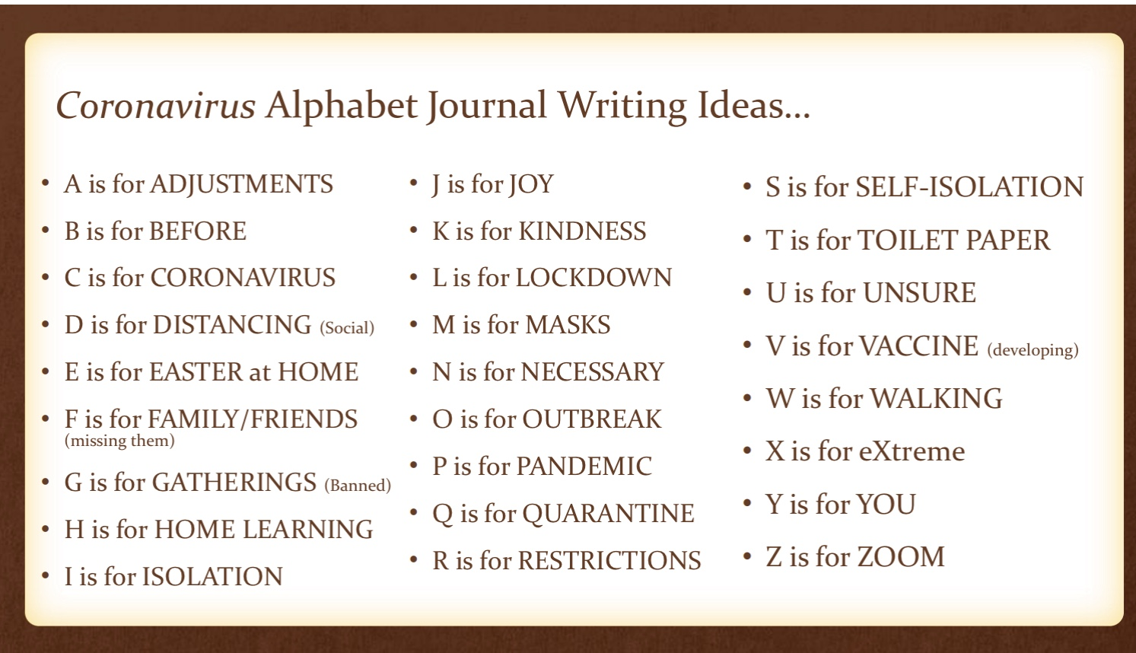

- Write at least ONE Journal Entry using the Coronavirus/COVID-19 Alphabet Journal Writing idea.

- You may use the Coronavirus/COVID-19 Alphabet Letter ideas provided, or you may come up with your own. (see attached sheet). If you use your own alphabet ideas, they must have a connection with the Coronavirus.

- As an EXTENSION Activity, you may like to write a Journal filled with each letter of the alphabet, over the next few weeks.

© 2020 Ipswich District Teacher – Librarian Network · Curious Creatures, Wild Minds
My Coronavirus/COVID-19 Alphabet Journal Writing Ideas…
A is for | N is for
B is for | O is for
C is for | P is for
D is for | Q is for
E is for | R is for
F is for | S is for
G is for | T is for
H is for | U is for
I is for | V is for
J is for | W is for
K is for | X is for
L is for | Y is for
M is for | Z is for

© 2020 Ipswich District Teacher – Librarian Network · Curious Creatures, Wild Minds

Example: Coronavirus/COVID-19 Alphabet Journal Writing

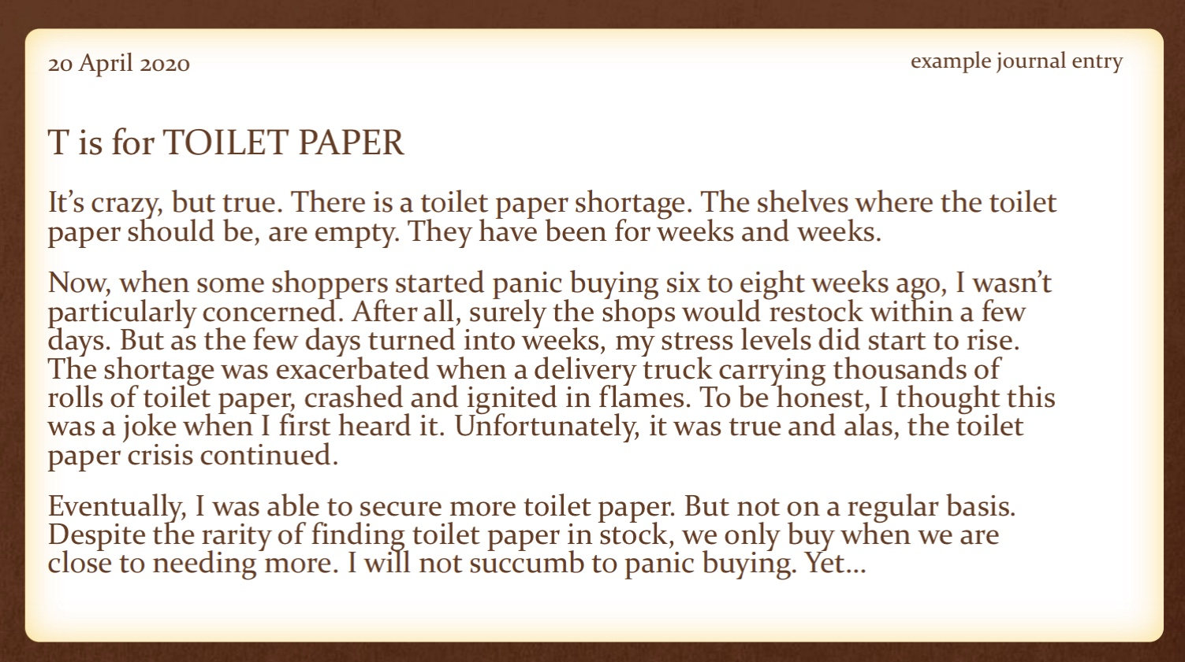

© 2020 Ipswich District Teacher – Librarian Network · Curious Creatures, Wild Minds

