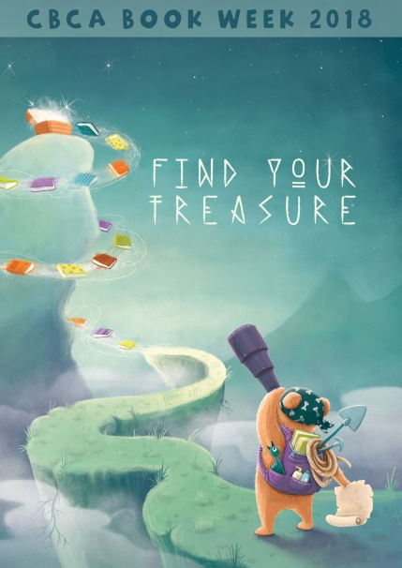
CBCA Book Week 2018
Attention:
Library/Resource Centre/Literacy coach
CBCA Book Week will be held 18-25 August and the theme for this year is
Find Your Treasure. The Ipswich District Teacher-Librarian Network is producing a book of ideas & activities covering the theme, reading promotion and selected books from the Children’s Book Council of Australia Book of the Year Awards.
The Book contains
- Blackline masters
- Activities and ideas including displays
- Ideas suitable for libraries and classrooms to help celebrate Book Week

The Ipswich District Teacher-Librarian Network is a Major Donor to the Children’s Book Council of Australia Awards Foundation
Pre-order now - Book available by END of June
How to order: Choose 1 of the following methods
- Mail order form to: Ipswich District Teacher – Librarian Network,
126 Cascade Street, Raceview QLD 4305
- FAX your order to (07) 3294 3196
- Email idtlnet@bethany.qld.edu.au
- Order online http://idtl.net.au/book-week.php
PLEASE NOTE: Your invoice will be sent with your order.
DO NOT SEND PAYMENT WITH ORDER as we have to add postage costs.
Estimated postage for Australia 1-2 copies - $5.00 per book sent in separate envelopes.
Express postage within Australia $8.00 for one book, 3 or more books up to 3kg - $14.00 per bag or $17.00 express.
Overseas Orders $17.00 per book | ABN 22 021 972 540
--------------------------------------------------------------------------------------------------------------------------------------------------- ORDER FORM BLOCK/PRINTED LETTERS PLEASE
School/Institution: _____________________________________________________________________
Mark order Attention to: ________________________________________________________________
Address to be sent: _____________________________________________________________________
City/Town: ____________________________________State:_______________Postcode:___________
Email Address: ________________________________________________________________________
Phone: ( ) __________________________________Fax: ( ) ________________________________
Purchase Order Number:________________________ Date Ordered:____________________________
Qty:_______ copies of Find Your Treasure (ISBN 978-0-6480212-1-6) @ $32.00 per copy + postage and handling (includes GST)
Other instructions: ________________________________________________________________________

