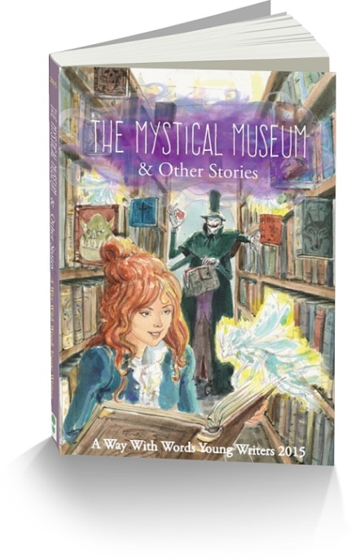
Attention: Library/Resource Centre/Literacy coach
The Mystical Museum & Other Stories
A Way with Words Young Writers 2015
“All over the world there are mysteries that need to be solved. They are always solved by adults with huge magnifying glasses and big, fancy badges. But never children. Except for one………….”
So begins the story of The Mystical Museum, just one of the amazing stories written by a group of young writers. Read their stories about trolls, magical libraries and museums, zombies and witches. Stories about life and death, love and hate. This book has it all.
This book was written by a group of young writers aged 9 -12 over three days at the 2015 A Way With Words writing workshop with popular author Brian Falkner. It contains 14 stories varying in length and has 211 pages with an illustration for each story by Lachlan Creagh.
This book can be used by teachers as a model to show what other children have written, or simply added to your library collection. Book Trailer https://www.youtube.com/watch?v=1bK01PQh2JA

Mail order form to Ipswich District Teacher – Librarian Network,
C/- Bethany Lutheran Primary School, 126 Cascade Street Raceview QLD 4305 or
FAX :- your order to (07) 3294 3196 or Email:- idtlnet@bethany.qld.edu.au
ABN 22 021 972 540
NOTE: Your invoice will be sent with your order. Do not send payment with order as we have to add postage costs. Estimated postage for Australia for 1 book $6.20
ORDER FORM
BLOCK/PRINTED LETTERS PELASE
School/Institution:____________________________________________________
Attention order to:_____________________________________________________
Address to be sent:________________________________________________
City/Town:__________________________ State:_______________Postcode:_______
Email Address:________________________________________________________
Phone:____________________________Fax:_______________________________
Purchase Order Number:________________________Date Ordered:____________
Qty:_________copies of “The Mystical Museum & Other Stories”
@ $9.99 per copy + postage and Handling (Includes GST)

